Date: February 18, 2025

To: Weber County Board of County Commissioners

From: Ronna Tidwell

Community Development Department

Agenda Date: February 25, 2025

Subject: **Request to Declare Parcel Number 07-070-0022 as Surplus Property**

Attachments: A - Aerial Vicinity Map

B - Ownership Plat

# _____________________________________________________________________________________

**Summary:**

A Weber County owned parcel of land, identified as Tax ID #07-070-0022, was acquired by the County through a tax sale process and deed executed in 1979. The parcel contains approximately .13 acres and is located approximately 552 W 4900 S, in Riverdale. See Attachment A for a vicinity map and Attachment B for the County Recorder’s ownership plat map.

The County has reached out to adjacent property owner’s and there is interest from one and the County has consider selling the subject parcel.

Weber County has no intended use for this property; therefore, it is recommended that the parcel be declared as surplus and offered to the adjacent property owner. In order to convey real property, the County Commission must first take action to declare this parcel as surplus property.

**Property Description:**

07-070-0022

PART OF LOT 13, BLOCK 2, TIBBITT'S SUBDIVISION, RIVERDALECITY, WEBER COUNTY, UTAH: BEGINNING AT THE SOUTHEAST CORNER OF LOT 7, AND RUNNING THENCE NORTH 0D22' EAST 113.50 FEET, THENCE SOUTH 89D38' EAST 5 FEET, THENCE SOUTH 0D22' WEST 113.50 FEET, THENCE SOUTH 89D38' WEST 5 FEET TO THE POINTOF BEGINNING.

Attachment A

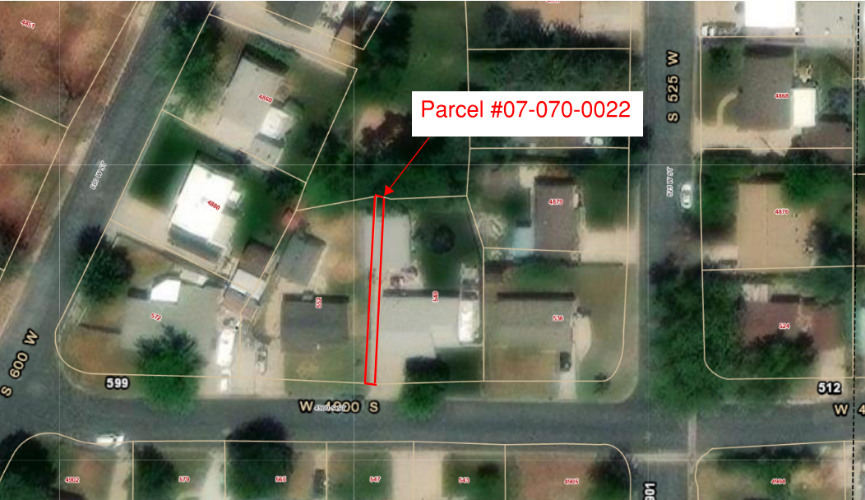

Attachment B

